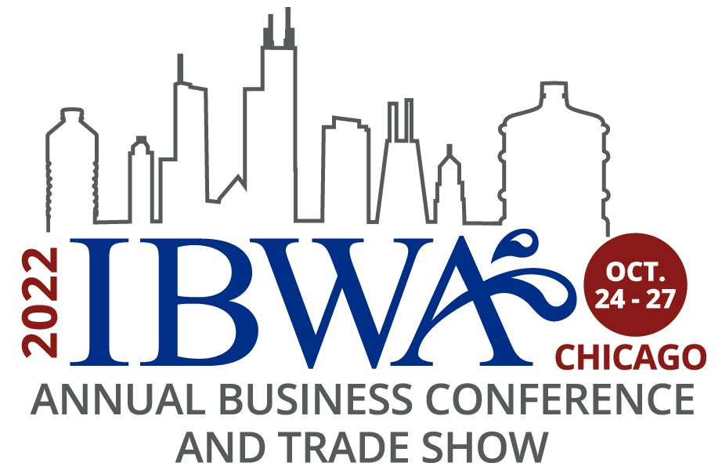

Palmer House Hilton, Chicago, Illinois
Monday, October 24 – Thursday, October 27, 2022
(Held in conjunction with PACK EXPO International**)
15 Education Sessions: 16.75 CEUs (8.5 technical; 8.25 business) (Current as of 10-10-22)

Sunday, October 23
9:00 am – 5:00 pm PACK EXPO International McCormick Place

Monday, October 24
10:00 am – 5:30 pm IBWA Registration Adams Foyer, 6th Floor
***************

11:00 am – 12:00 pm IBWA Education Committee Meeting* Wabash Room, 3rd Floor
1:00 pm – 2:00 pm Cybersecurity Basics: How to Protect Your Salon 7-9, 3rd Floor
Business and Customers (1 Business CEU)

1:00 pm – 2:00 pm IBWA Environmental Sustainability Committee Wabash Room, 3rd Floor
Meeting*

2:15 pm – 3:15 pm Reaching Sustainability Goals Through Collaborative Salon 4-6, 3rd Floor
Treasure Hunts (1 Technical CEU)
2:15 pm – 3:15 pm Building a Purpose Driven Culture in Route Salon 7-9, 3rd Floor
Operations (1 Business CEU)

2:15 pm – 3:15 pm IBWA Supplier and Convention Committee Meeting* Wabash Room, 3rd Floor
3:30 pm – 4:30 pm Making the IBWA Audit Program Work For You Salon 4-6, 3rd Floor
(1 Technical CEU)
3:30 pm – 4:30 pm Charting Water Source Resiliency in a Changing Salon 7-9, 3rd Floor
Climate (1 Technical CEU)

3:30 pm – 4:30 pm IBWA Government Relations Committee Meeting* Wabash Room, 3rd Floor
4:45 pm – 5:30 pm Key Issues Forum: What Keeps You Salon 7-9, 3rd Floor
Up at Night? (.75 Business CEUs)

Monday, October 24 (continued)
5:30 pm – 7:00 pm IBWA Welcome Reception Chicago Room, 5th Floor

9:00 am – 5:00 pm PACK EXPO International McCormick Place

Tuesday, October 25
7:15 am – 5:15 pm IBWA Registration Adams Foyer, 6th Floor
7:30 am – 9:00 am Continental Breakfast Adams Foyer, 6th Floor
***************

7:00 am – 9:00 am IBWA Executive Committee Meeting (closed) Price Room, 5th Floor
and Plated Breakfast

8:45 am – 9:45 am Charting a Course for Future Workforce Salon 4-6, 3rd Floor
Decisions (1 Business CEU)

8:45 am – 9:45 am The Latest Developments in Water Filtration: Salon 7-9, 3rd Floor
A Part of High-Quality Assurance (1 Technical CEU)
8:45 am – 10:00 am IBWA Communications Committee Meeting* Wabash Room, 3rd Floor

10:00 am – 11:00 am Emerging Contaminants: Keeping Updated on Salon 4-6, 3rd Floor
What’s New (1 Technical CEU)
10:00 am – 11:00 am Preparing Your Business for an Economic Downturn Salon 7-9, 3rd Floor
(1 Business CEU)

10:15 am – 11:45 am IBWA State Affairs Task Force* Wabash Room, 3rd Floor
11:45 am – 12:15 pm IBWA State and Regional Associations Committee Wabash Room, 3rd Floor
Meeting*

11:15 am – 12:15 pm Alan Leff Memorial Lecture: Machine Learning in Salon 4-6, 3rd Floor
Modeling the Elusive Daily Water Requirement
(1 Technical CEU)
12:30 pm – 4:00 pm IBWA Trade Show and Lunch Monroe Ballroom, 6th Floor
4:15 pm – 5:30 pm DWRF Trustees Meeting Wabash Room, 3rd Floor

7:00 pm – 9:30 pm DWRF Casino Night Fundraiser (Ticketed Event) Chicago Room, 5th Floor

9:00 am – 5:00 pm PACK EXPO International McCormick Place

Wednesday, October 26
7:00 am – 5:00 pm IBWA Registration Adams Foyer, 6th Floor

***************
8:00 am – 10:30 am IBWA General Session, Annual Business Meeting, Adams Ballroom, 6th Floor
Awards Ceremony, and Keynote Presentation and
Continental Breakfast (1.5 Business CEUs)
Wednesday, October 26 (continued)
10:45 am – 11:45 am IBWA Membership Committee Meeting * Wabash Room, 3rd Floor
10:45 am – 11:45 am Bottled Water Sales Trends (1 Business CEU) Salon 7-9, 3rd Floor

1:15 pm – 2:15 pm Defining and Recognizing Good Water Stewardship Salon 7-9, 3rd Floor
(1 Technical CEU)

1:30 pm – 3:00 pm IBWA Technical Committee Meeting* Wabash Room, 3rd Floor
2:30 pm – 3:30 pm Elections Have Consequences: How Will the Midterm Salon 7-9, 3rd Floor
Elections Impact State and Federal Policies in 2023?
(1 Business CEU)

3:45 pm – 5:15 pm CPO Study Session (1.5 Technical CEUs) Salon 7-9, 3rd Floor

9:00 am – 3:00 pm PACK EXPO International McCormick Place

Thursday, October 27
8:00 am – 10:00 am IBWA Board of Directors Meeting* Wabash Room, 3rd Floor and Continental Breakfast

8:00 am – 11:00 am IBWA CPO Exam (Ticketed Event)* Grant Park Parlor, 6th Floor
*IBWA Membership Required for Attendance

** PACK EXPO International (shuttles to/from hotels will be provided; load at hotel – Wabash Street)
McCormick Place Exhibits located in all buildings: North, South, West, and Lakeside Center
Show Schedule 9:00 am – 5:00 pm October 23 -25 (Sunday – Tuesday)
9:00 am – 3:00 pm October 26 (Wednesday)
Shuttle Schedule 7:00 am – 10:30 am; 3:00 pm – 6:00 pm (Sunday – Tuesday)
7:00 am – 10:30 am; 1:00 pm – 4:00 pm (Wednesday)

